Breakout Board for Vishay IR LED and PhotoTransistor

# Overview

This is a pair of boards to enable evaluation of the Vishay VSMB2020 IR LED and VEMT2023 IR Phototransistor. A basic implementation of the Vishay application notes is used to enable engineers to quickly evaluate the performance of these sensors. Many very useful sensors are available in packages that are difficult to quickly evaluate so we hope this is a meaningful addition to your toolbox.

# Design Notes

The values chosen for the onboard components are based on the device datasheets:

[VSBM2020X01 High Speed Infrared Emitter](https://www.vishay.com/docs/81930/vsmb2000.pdf)

[VEMT2023X01 NPN Infrared Phototransistor](https://www.vishay.com/docs/84162/vemt2003x01.pdf)

# Schematics

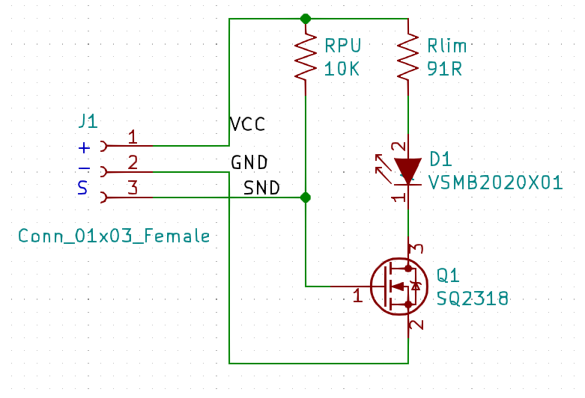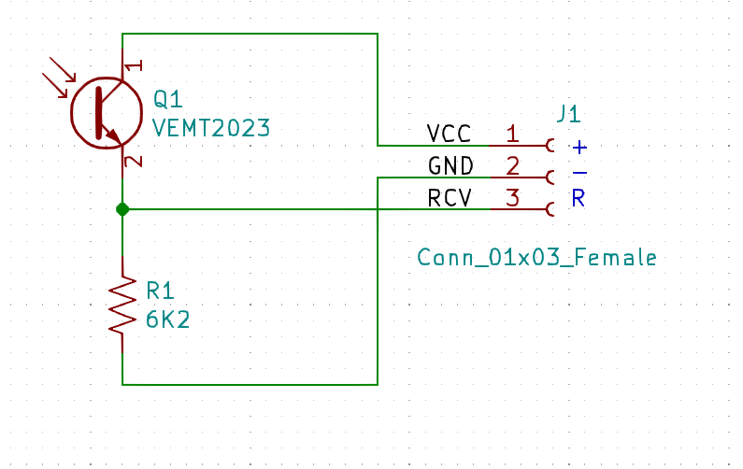

For the sender side, the Rlim of 91Ohms corresponds to roughly 40mA from a 5V supply. A small MOSFET is placed to enable the IR LED from a standard GPIO rather than sourcing it directly.

For the receiver side, the 6.2KOhm resistor provides a weak pulldown; some circuitry on the host side will be needed to either amplify the signal for a linear application, or a simple transistor comparator for a “trip threshold” style output.

# Hookup

|  |  |
| --- | --- |
| R | Receive – output from phototransistor |
| S | Send – input to IR LED control, active-HI with 10K pullup resistor |
| - | Ground |
| + | Supply, maximum 5V |

The header is a breadboard-friendly 0.1” spacing and can be either direct-wired or the engineer may choose a header as shown above. The center mounting hole is electrically isolated and will accept up to a 6-32 machine screw. This hole is aligned with the center axis of both sensors.